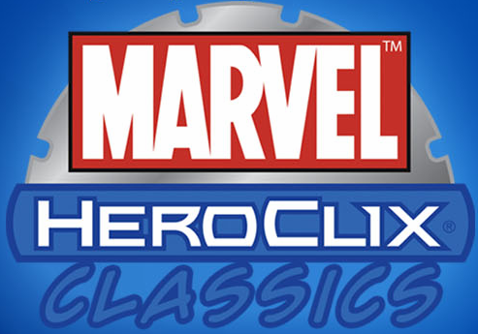
Marvel HeroClix: Classics Battle Packs

Product Information
Domestic Orders Due: TBA
Rest of World Orders Due: TBA

Sellable Unit: |  | 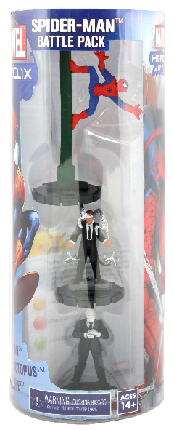
Stock # (Case): | 70010
Title: | Marvel HeroClix: Classics Battle Packs Case
MSRP: | $5.99 per Battle Pack
Case UPC: | 63448270010-5
Case Pack: | 16 Battle Packs per case (4 of each Battle Pack)
Case Size (inches): | 13.4 (L) x 10.2 (W) x 8.9 (H) (estimated)
Case Gross Weight (pounds): | 3.66 (estimated)
Hang Tab: | Yes
Country of Origin: | China
Expected Release: | TBD

Fight for Justice!

Description
The world’s most spectacular heroes have come together to fight the forces of evil, and they want your help! Marvel™ HeroClix®: Classics puts the power in your hands!

HeroClix is a fun, action-packed game where you become your favorite superhero and fight the world’s most menacing villains. Look for all four Marvel HeroClix: Classics Battle Packs.

Spider-Man™ Battle Pack (#70006) |  | 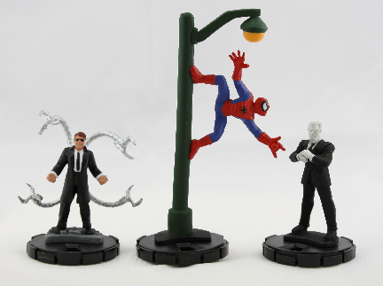
Contents: | - Spider-Man  - Doctor Octopus™  - Tombstone™  - 3 character cards

Marvel Heroes (#70007) |  | 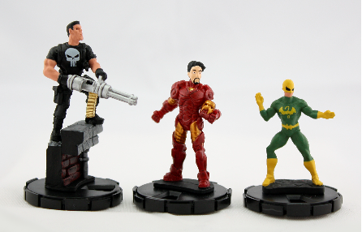
Contents: | - Iron Man™  - Iron Fist™  - Punisher™  - 3 character cards

Fantastic Four™ vs. Dr. Doom™ (#70008) |  | 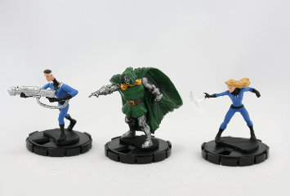
Contents: | - Mr. Fantastic™  - Invisible Woman™  - Dr. Doom  - 3 character cards
Fantastic Four vs. Mole Man™ (#70009) |  | 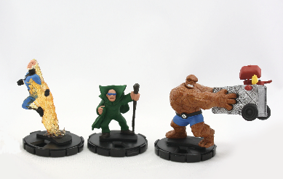
Contents: | - Human Torch™  - Thing™  - Mole Man  - 3 character cards

